Family Activity Scale
This is a short assessment of child-centred activities that take place in and outside of the home. It aims to identify the extent to which the children are offered the opportunity for family activities as well as friendships, hobbies and interests and independent play. The activities can be adapted depending on children’s ages, any additional needs, and the family circumstances. They are selected to be predominantly no cost or low cost activities to avoid scores being impacted by family income where possible. There is a section for preschool age children which can be completed with parents however you can also add your own observations or other evidence that supports this. The section for children over five has two parts that can be completed with children and parents separately to gain both viewpoints.
The higher the score, the more child-centred activities are offered. There is no cut-off; the tool is designed to support assessment and encourage parents to think about the stimulation provided to their children.

Child(ren)’s Name(s) |  | Parent/Carer’s name(s)
Practitioner completing form |  | Date completed

Adapted from Family Pack of Questionnaires and Scales, Department of Health, The Stationery Office

Family Activity Scale for children under 5

 |  | Tick if yes | Notes
1 | Does your child regularly attend a nursery/preschool/ parent and toddler group? | ☐
2 | Did you celebrate your child’s last birthday? | ☐
3 | Did you celebrate any other special occasions/festivals/holidays as a family over the last year? | ☐
4 | Have you read a story to your child in the last week? | ☐
5 | Have you eaten a meal as a family in the last week? | ☐
6 | Have you and your child visited friends/family members with young children in the last month? | ☐
7 | Have you played with your child in the last week? | ☐
8 | Have you been somewhere different for a family day out or a holiday in the last six months? | ☐
9 | Has your child engaged in creative activities/messy play/sensory play in the last month? | ☐
10 | Have you taken your child to a park or playground in the last month? | ☐
Can you think of any other things you have done with your child/as a family in the last week?

Can you think of any other things you have done with your child/as a family in the last month?

Can you think of any other things you have done with your child/as a family in the last 6 months?

Family Activity Scale for children over 5 – parent version
 |  | Tick if yes | Notes
1 | Have you taken your child to the park/playground in the last month? | ☐
2 | Has your child had a friend over to visit in the last 3 months? | ☐
3 | Has your child been to visit a friend in the last 3 months? | ☐
4 | Have you celebrated any special occasions as a family in the last year? Eg birthdays/festivals/religious holidays | ☐
5 | Have you had a family day out/holiday in the last 6 months? | ☐
6 | Has your child stayed with friends or family members in the last year? | ☐
7 | Has your child attended any activities outside/after school in the last 3 months eg football, cubs, dance? | ☐
8 | Has your child been for a trip to somewhere like cinema/ museum/zoo/sports match/local event in the last 6 months? | ☐
9 | Has your child participated in any sports/physical activities other than in school in the last 3 months? eg swimming/skating/tennis | ☐
10 | Have you played a game/other activity as a family in the last 3 months? | ☐
Can you think of any other things you have done with your child/as a family in the last week?

Can you think of any other things you have done with your child/as a family in the last month?

Can you think of any other things you have done with your child/as a family in the last 6 months?

Family Activity Scale for children over 5 – child version
How often do you do these things? Tell me about them
Celebrate special occasions | Have friends over to play | Family days out or holidays | Go to the park
Go to friends’ houses | Play sport/activities | Special trips out eg zoo, cinema | Play a game as a family  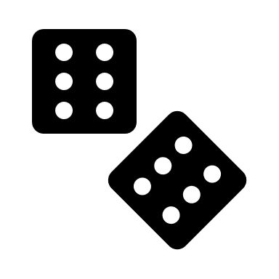
Go to clubs | Stay with friends/family  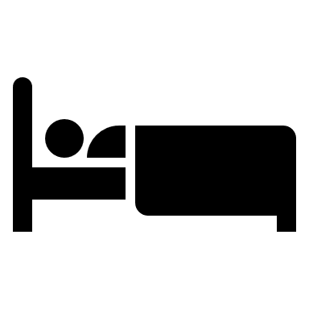 | Anything else I do with my family | Anything else I do without my family

