This activity can be completed with school age children to help practitioners understand their lived experience and the care provided to them. Children can draw, write, or talk about what they usually do during each part of their day. The tool can be adapted to meet the needs of the child or for the child’s age.
Useful prompts/questions/ideas for practitioners to think about:
Waking Up  What time does the child get up?  Do they wake up by themselves or does someone wake them?  Who else is awake? Who is at home? | Getting Ready  Does someone help the child get dressed?  Do they have school uniform?  Do they have clean/well-fitting/weather appropriate clothes?  Do they brush their teeth? | Breakfast  What does the child eat for breakfast?  Is there food in the cupboards/fridge?  Who prepares this?  Where is breakfast eaten? | Going to School  How does the child get to school?  How long does it take?  Are they usually on time for school?  Does someone take them to school, or do they go alone?
School Day  Does the child enjoy school?  What are their favourite/least favourite things about school?  Do they have everything they need?  What is their teacher like?  Do they find learning easy/difficult? | Lunch  Does the child have school dinner or packed lunch?  What do they eat? Are they hungry at school? | Break Time  What does the child do at break times?  Do they have friends?  Are there any issues with other children such as bullying? | Going Home  How does the child get home from school?  Are they picked up? Is this usually on time?  Do they ever play with friends after school?  Do they go to after school club/ childcare?
At Home  Who is at home when the child returns from school?  Do they have homework and does anyone help with this?  Do they have a snack at home?  Do they have any pets? | Play/Activities  Does the child take part in any extra-curricular clubs or activities – sports/arts/music/social?  What toys/games do they play with?  Do they play video games? Is anyone monitoring online activity?  Do they play outside? Is this safe? | Dinner  Does the child usually eat at the same time?  What do they eat? Where?  Who prepares the evening meal?  Do the family eat together? | Bath  How often does the child have a bath/shower?  Does someone help them with this/prompt them?  Do they brush their teeth?
Bedtime  Does the child go to bed at the same time every night?  Who decides when it is bedtime?  Do they have what they need in their bedroom – bed/clean bedding/curtains?  Do they have a drink/snack before bed? | Sleep  Where does the child sleep?  Do they share a bedroom?  Who else is in the house at night time?  Do they wake up at night and what happens if they do? | Weekends/School holiday  What does the child do at weekends?  Do they have chores to do?  Who looks after them at weekends/ holidays?  Do they have to look after anyone else?  Do they visit family/friends?  Is there enough food at home? | Days out  Do the family have days out/ celebrations/holidays?  What does the child enjoy about these?  Where do they like to go?

Name
Date

Waking Up | Getting Ready for the Day | Breakfast Time | Going to School
The School Day | Lunch Time | Break Times | Going Home
At Home | Play/Activities | Dinner Time | Bath/Washing
Bedtime  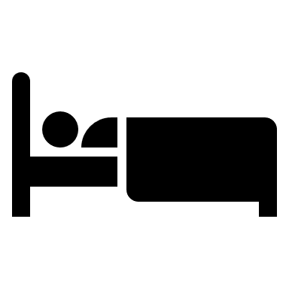 | Sleeping | Weekends/School Holidays | Holidays/Days Out

