Appendix 1
The subscales included and tested in the current study (their belonging in the original scales, the modified full scales and in the short scales)

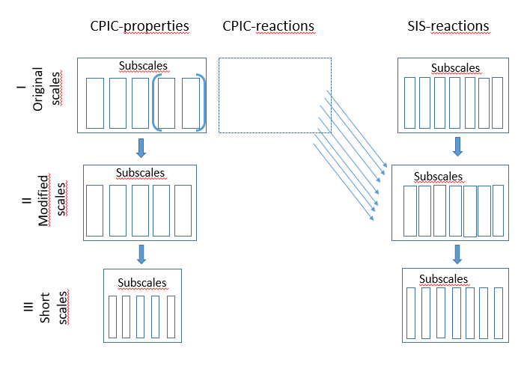

Appendix 2

Standardized factor loadings for all CPIC-properties items and internal consistency for the CPIC-properties-subscales.
Items | Factor 1  Frequency | Factor 2  Intensity | Factor 3  Resolution | Factor 4  Child Content | Factor 5  Triangulation
B29: My parents hardly ever argue | -.902
B11: They may not think I know it, but my parents argue or disagree a lot | .863
B20: I often see my parents arguing | .846
B37: My parents often nag and complain about each other around the house | .813
B1: I never see my parents arguing or disagreeing | -.521
B6: My parents get really mad when they argue |  | -.826
B24: When my parents have an argument they say mean things to each other |  | -.813
B33: When my parents have an argument they yell a lot |  | -.803
B38: My parents hardly ever yell when they have a disagreement |  | .773
B14: When my parents have a disagreement they discuss it quietly |  | .614
B40: My parents have broken or thrown things during an argument |  | -.491
B12: Even after my parents stop arguing they stay mad at each other |  |  | -.967
B48: My parents still act mean after they have had an argument |  |  | -.894
B21: When my parents disagree about something, they usually come up with a solution |  |  | .799
B30: When my parents argue they usually make up right away |  |  | .795
B4: When my parents have an argument they usually work it out |  |  | .747
B41: After my parents stop arguing, they are friendly toward each other |  |  | .667
B31: My parents usually argue or disagree because of things that I do |  |  |  | .950
B39: My parents often get into arguments when I do something wrong |  |  |  | .923
B22: My parents' arguments are usually about something I did |  |  |  | .922
B5: My parents often get into arguments about things I do at school |  |  |  | .832
B27: My mom wants me to be on her side when she and my dad argue |  |  |  |  | .929
B9: I feel caught in the middle when my parents argue |  |  |  |  | .881
B44: My dad wants me to be on his side when he and my mom argue |  |  |  |  | .827
B36: I feel like I have to take sides when my parents have a disagreement |  |  |  |  | .731
 | Pα = .75 | Pα = .71 | Pα = .75 | Pα = .80 | Pα = .66
 | Oα = .89 | Oα = .85 | Oα = .90 | Oα = .79 | Oα = .87
Note. Pα= Pearson based alpha, Oα=Ordinal alpha. All items retained in the short scale are in italics.

Appendix 3

Standardized factor loadings for all modifies SIS- items and internal consistency for the modified SIS-subscales.
Items | Factor 1  Emotional reactivity | Factor 2  Dysregulation | Factor 3  Avoidance | Factor 4  Involvement | Factor 5  Blame | Factor 6  Destructive family representations
B8_2: When my parents argue, I feel scared | .882
B8_4: When my parents argue, I feel unsafe | .880
B10_12: When my parents argue, I can’t stop thinking about their problems | .837
B8_1: When my parents argue, I feel sad | .815
B9_1: After my parents argue, it ruins my whole day | .812
B10_3: When my parents have an argument, I try to hide what I’m feeling | .786
B9_2: After my parents argue, I can’t seem to calm myself down | .752
B9_3: After my parents argue, I can’t seem to shake off my bad feelings | .696
B8_3: When my parents argue, I feel angry | .623
B10_4: When my parents have an argument, I yell at/say unkind things to people in my family |  | .828
B10_9: When my parents have an argument, I try to clown around or cause trouble |  | .630
B10_6: When my parents have an argument, I don’t know what to do |  |  | .867
B10_2: When my parents have an argument, I keep really still/almost frozen |  |  | .788
B10_11: When my parents have an argument, I try to be really quiet |  |  | .782
B10_16: When my parents have an argument, I feel like staying as far away as possible |  |  | .770
B10_18: When my parents have an argument, I try to get away from them |  |  | .761
B10_15: When my parents have an argument, I wait and hope things get better |  |  | .727
B10_1: When my parents have an argument, I feel sorry for one/both |  |  |  | .874
B10_14: When my parents have an argument, I try to comfort one/both |  |  |  | .755
B10_17: When my parents have an argument, I try to pretend things are better |  |  |  | .733
B10_8: When my parents have an argument, I try to be on my best behavior |  |  |  | .641
B10_13: When my parents have an argument, I try to solve the problem for them |  |  |  | .561
b10_7: When my parents have an argument I try to distract them by bringing up other things |  |  |  | .542
B10_10: When my parents have an argument, I feel caught in the middle |  |  |  |  | .980
B10_19: When my parents have an argument, I feel like they are upset with me |  |  |  |  | .935
B10_23: When my parents have an argument, I feel like it’s my fault |  |  |  |  | .847
B43: My parents blame me when they have arguments |  |  |  |  | .824
B10_27: When my parents have an argument, I think they blame me |  |  |  |  | .780
B19: It's usually my fault when my parents Argue |  |  |  |  | .744
B28: Even if they don't say it, I know I’m to blame when my parents argue |  |  |  |  | .718
B10_25: When my parents have an argument, I worry about what they’ll do next |  |  |  |  |  | .920
B10_24: When my parents have an argument, I worry about my family’s future |  |  |  |  |  | .876
B17: When my parents argue, I worry about what will happen to me |  |  |  |  |  | .869
B26: When my parents argue I'm afraid that something bad will happen |  |  |  |  |  | .868
B10_28: When my parents have an argument I wonder if they will separate/divorce |  |  |  |  |  | .861
B42: When my parents argue, I'm afraid that they will yell at me too |  |  |  |  |  | .783
B10_26: When my parents have an argument I know they don’t know how to get along |  |  |  |  |  | .674
B35: When my parents argue, I worry that one of them will get hurt |  |  |  |  |  | .605
 | Pα = .85 | Pα = .32 | Pα = .83 | Pα = .76 | Pα = .77 | Pα = .85
 | Oα = .93 |  | Oα = .90 | Oα =. 85 | Oα = .84 | Oα = .90
Note. Pα= Pearson based alpha, Oα=Ordinal alpha. All items retained in the short scale are in italics.

